Assignment Module 1

Q.1 What is SDLC?

Ans. SDLC (Software Development Life Cycle) is a systematic process for Planning, building, testing, and maintaining software.

Q.2 What is software testing?

Ans. Software testing is a process used to identify correctness, completeness, and quality of the developed computer software.

Q.3 What is agile methodology?

Ans. Agile SDLC model is a combination of iterative and incremental process models with focus on process adaptability and customer satisfaction by rapid delivery of working software product.

Q.4 What is SRS

Ans. A Software Requirements Specification (SRS) is a complete description of the behavior of the system to be developed. It includes a set of use cases that describe all of the interactions that the users will the software.

Q.5 What is oops

OPPS stands for Object-Oriented Programming System, a programming paradigm that organizes software design around objects, which contain data and code, rather than functions and logic.

Q.6 Write Basic Concepts of oops

Ans. OOPs stands for Object-Oriented Programming system.

There are basic concepts of oops.

1. Class
2. Object
3. Encapsulation
4. Inheritance
5. Polymorphism
6. Abstraction

Q.7 What is object

Ans. Object is an instances of a class. Class variables creation i.e.

Q.8 What is class

Ans. Class is a collection of data members (variables) and member function (method, process) with its behaviour.

Q.9 What is encapsulation

Ans. Encapsulation is wrapping up of data into single unit. i.e., data hiding purpose at small level.

Q.10 What is inheritance

Ans. Inheritance is properties of parent class extends into child class.

Main purpose: extensibility, reusability

There are mainly 5 types

1. Single
2. Multilevel
3. Hierarchical
4. Multiple
5. Hybrid

Q.11 What is polymorphism

Ans. Polymorphism is an ability to take one name having many forms

There are mainly 2 types.

1. compile time (method overriding)
2. run time (method overriding)

Q.12 Draw Usecase on online bill payment system (paytm)

Ans. 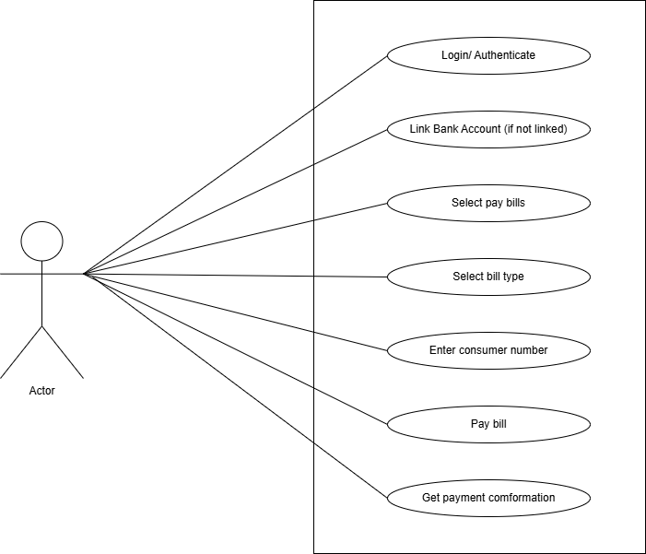

Q.13 Draw Usecase on banking system for customers.

Ans. 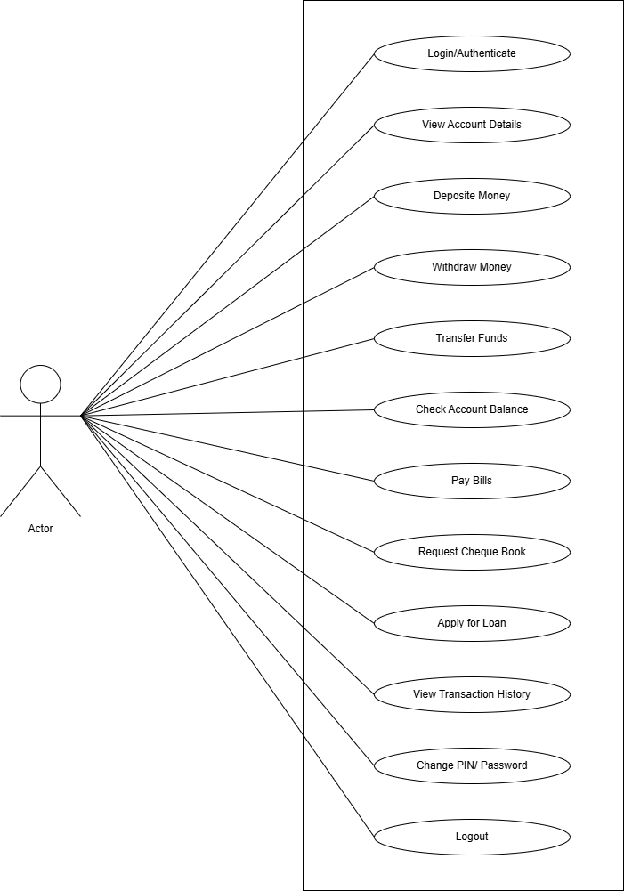

Q.14 Draw Usecase on Broadcasting System.

Ans. 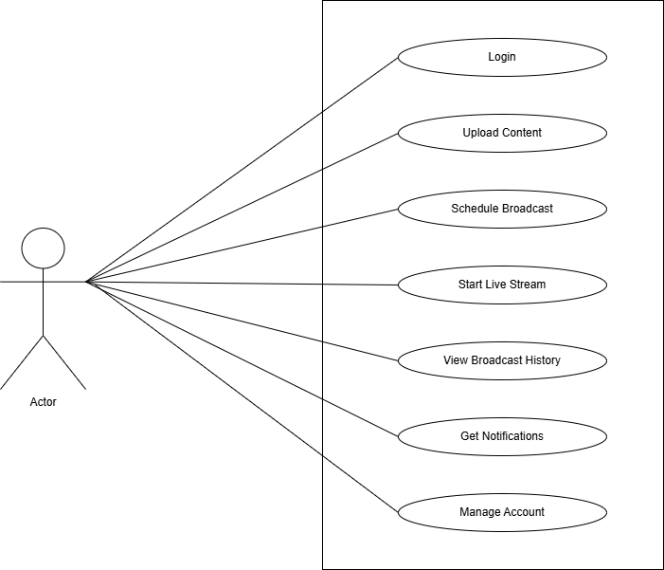

Q.15 Write SDLC phases with basic introduction

Ans. In SDLC(Software Development Life Cycle) Requirements gathering, analysis, design, implementation, testing, and maintenance.

1. Requirements gathering

* In requirement gathering establish customer needs and expectations.

1. Analysis

* The analysis phase defines the requirements of the system, independent of how these requirements will be accomplished.

1. Design

* Design Architecture Document implementation plan.
* Creating the software’s architecture, user interface (UI), and database structure.

1. Implementations

* Translating the design into actual code.
* In the implementation phase, the team builds the components either from scratch or by composition.

1. Testing

* Testing phase is a separate phase which is performed by a different team after the implementation is completed.
* Ensuring the software meets the requirements and is free from defects.

1. Maintenance

* Software maintenance is the process of enhancing and optimizing deployed software (Software release), as well as fixing defects.

Q.16 Explain Phases of the waterfall model.

Ans. The Waterfall Model is also called the Classical Software Cycle.

The classical software lifecycle models software development as a step-by-step “waterfall” process between the various development phases.

Applications: Requirements are very well-documented, clear, and fixed. Product definition is stable. Technology is understood and is not dynamic. There are no ambiguous requirements.

Pros: Simple and easy to understand and use. Easy to manage due the rigidity of the model. Each phase has specific deliverables and a review process. Phases are processed and completed one at a time. Works well for smaller projects where requirements are very well understood.

Cons: High amounts of risk and uncertainty. Not a good model for complex and object-oriented projects. Poor model for long and ongoing projects. It is difficult to measure progress within stages. Cannot changing requirements.

Q. 17 Write phases of spiral model.

Ans. Bohem’s Spiral Model:

Planning: Determination of objectives, alternatives, and constraints.

Risk Analysis: Analysis of alternatives and identification/resolution of risks.

Engineering: Development of the “next level” product.

Customer Evolution: Assessment of the results of engineering.

Q.18 Write agile manifesto principles

Ans. Agile manifesto:

1. Individual interaction
2. Working Software
3. Customer collaboration
4. Responding to change

Q.19 Explain working methodology of agile model and also write pros and cons.

Ans. Agile Model – Working Methodology:

1. Divide the project into small parts called iterations or sprints (usually 1–4 weeks).
2. Plan the sprint with customer input.
3. Design, develop, and test the features during each sprint.
4. At the end of each sprint, deliver a working product or feature.
5. Review and get feedback from stakeholders.
6. Improve and move to the next sprint.

This process repeats until the final product is complete.

Pros of Agile:

* Customer involvement & satisfaction
* Quick delivery of working software
* Flexible to changes
* Easy to detect and fix issues early
* Continuous improvement

Cons of Agile:

* Needs active customer participation
* Hard to predict total cost and time
* Documentation can be light
* Not ideal for very large, complex projects
* Requires experienced team

Q.20 Draw usecase on OTT Platform.

Ans.

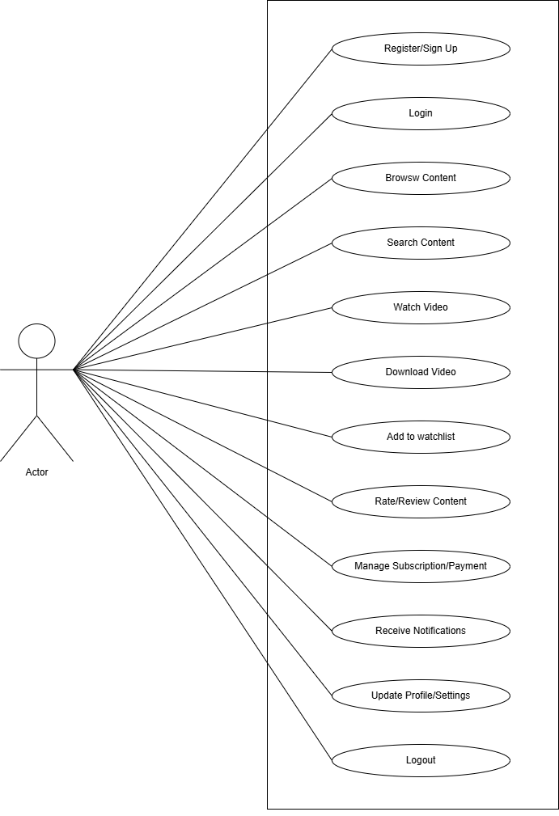

Q.21 Draw usecase on E-commerce application

Ans.

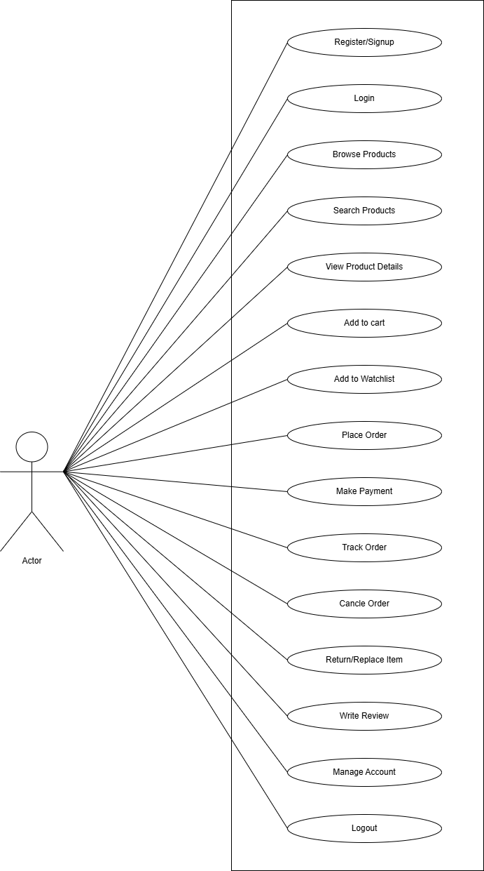

Q.22 Draw usecase on Online shopping product using payment gateway.

Ans.

